Unit I | Introduction

Learning Objectives:
By the end of this unit, the learners would be able to:
Understand the formulation of physical systems using differential equations.
Explain the existence and uniqueness of solutions for differential equation systems.
Understand the concept and properties of linear systems.
Solve systems of linear differential equations using suitable methods.
Explain the concept and construction of a fundamental matrix.
Understand fundamental matrices for non-autonomous systems.
Solve non-homogeneous systems using appropriate solution techniques.

Structure:
1.1 Introduction
1.2 Formulation of Physical Systems
1.3 Existence and Uniqueness Theorems
1.4 Linear Systems
1.5 Solution of Linear Systems
1.6 Fundamental Matrix
1.7 Fundamental Matrices for Non-Autonomous Systems
1.8 Solution of Non-Homogeneous Systems
1.9 Key Terms
1.10 Summary
1.11 Check Your Progress
1.12 Self-Assessment Questions
1.12.1 Short Answer Questions
1.12.2 Long Answer Questions
1.13 Case Study
1.14 References
1.15 E-References

1.1 Introduction

1.5 Solution of Linear Systems
The previous section established the theoretical structure of solutions to a linear system, namely that they form a vector space spanned by any fundamental set, but it gave no method for actually producing such a fundamental set. This section develops that method, restricting attention to homogeneous linear systems with constant coefficients,
where is a constant n×n matrix, and building the solution entirely from the eigenvalues and eigenvectors of .
Motivation: seeking exponential solutions
For a single first order equation with constant a, the solution is the familiar exponential x(t)=Ceat. This suggests seeking solutions of the vector system of the same exponential form,
x(t)=eλtv
where λ is a scalar constant and is a constant vector, both to be determined.
Substituting this trial form into the system,
x′(t)=λeλtv
Ax(t)=eλtAv
Setting these equal, since x(t) must satisfy x′=Ax,
λeλtv=eλtAv
Dividing through by the nonzero scalar eλt,
λv=Av
Av=λv
This is exactly the eigenvalue equation from linear algebra. So x(t)=eλtv solves the system precisely when λ is an eigenvalue of A and v is a corresponding eigenvector.
The characteristic equation
Eigenvalues of A are found by solving
det(A−λI)=0
a polynomial equation of degree n in λ, called the characteristic equation of A. For each root λ, a corresponding eigenvector v is found by solving
(A−λI)v=0
Case 1: real, distinct eigenvalues
Theorem. Suppose the n×n constant matrix A has n real, distinct eigenvalues λ1​,λ2​,…,λn​, with corresponding eigenvectors v1​,v2​,…,vn​. Then
x(1)(t)=eλ1​tv1​,x(2)(t)=eλ2​tv2​,…,x(n)(t)=eλn​tvn​
form a fundamental set of solutions, and the general solution is
x(t)=c1​eλ1​tv1​+c2​eλ2​tv2​+⋯+cn​eλn​tvn​
Proof.
Each x(i)(t) solves the system by the derivation given above.
Eigenvectors corresponding to distinct eigenvalues of a matrix are linearly independent, a standard fact from linear algebra: if c1​v1​+⋯+cn​vn​=0 with not all ci​ zero and the λi​ distinct, applying A−λj​I successively to eliminate terms leads to a contradiction unless every ci​=0.
At t=0, the Wronskian is
W(0)=det[v1​ v2​ ⋯ vn​]
which is nonzero since the eigenvectors are linearly independent, confirming, by the Wronskian test established previously, that the solutions are linearly independent on every interval, forming a fundamental set.
Worked demonstration: real distinct eigenvalues
Solve
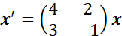
x′=(43​2−1​)x
The characteristic equation is
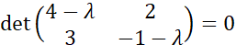
det(4−λ3​2−1−λ​)=0
(4−λ)(−1−λ)−6=0
−4−4λ+λ+λ2−6=0
λ2−3λ−10=0
(λ−5)(λ+2)=0
λ1​=5,λ2​=−2
For λ1​=5:
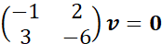
(−13​2−6​)v=0
giving −v1​+2v2​=0, so v1​=2v2​. Taking v2​=1,
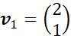
v1​=(21​)
For λ2​=−2:
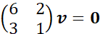
(63​21​)v=0
giving $3v_1+v_2=0, so $v_2=-3v_1 . Taking v1​=1,
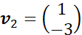
v2​=(1−3​)
The general solution is
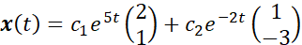
x(t)=c1​e5t(21​)+c2​e−2t(1−3​)
Case 2: complex eigenvalues
Since A is a real matrix, complex eigenvalues always occur in conjugate pairs λ=α±iβ, with corresponding conjugate eigenvectors v=a±ib.
Theorem. If λ=α+iβ has eigenvector v=a+ib, then two real, linearly independent solutions are given by
x(1)(t)=eαt(acosβt−bsinβt)
x(2)(t)=eαt(asinβt+bcosβt)
Proof.
The complex function eλtv is a solution, by the earlier derivation, valid for complex λ,v as well as real.
Expanding using Euler's formula,
eλtv=e(α+iβ)t(a+ib)=eαt(cosβt+isinβt)(a+ib)
=eαt[(acosβt−bsinβt)+i(asinβt+bcosβt)]
Since A is real, the real and imaginary parts of a complex solution are each themselves real solutions, a fact verified by substituting the complex solution into x′=Ax, splitting into real and imaginary parts, and noting both parts separately satisfy the real equation.
So x(1)(t) and x(2)(t), the real and imaginary parts respectively, are both real solutions, and their linear independence follows from the linear independence of the original complex eigenvectors.
Worked demonstration: complex eigenvalues
Solve
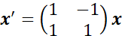
x′=(11​−11​)x
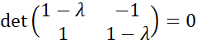det(1−λ1​−11−λ​)=0
(1−λ)2+1=0
λ2−2λ+2=0
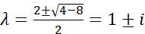λ=22±4−8​​=1±i
For λ=1+i:
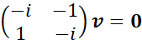
(−i1​−1−i​)v=0
giving −iv1​−v2​=0, so v2​=−iv1​. Taking v1​=1,
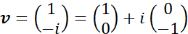
v=(1−i​)=(10​)+i(0−1​)
so a=(1,0)T, b=(0,−1)T, α=1, β=1.
x(1)(t)=et[(10​)cost−(0−1​)sint]=et(costsint​)
x(2)(t)=et[(10​)sint+(0−1​)cost]=et(sint−cost​)
The general solution is
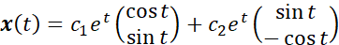
x(t)=c1​et(costsint​)+c2​et(sint−cost​)
Case 3: repeated eigenvalues
When an eigenvalue λ has algebraic multiplicity k but fewer than k linearly independent eigenvectors, additional solutions involving powers of t multiplied by exponentials are required, using generalized eigenvectors.
Theorem. If λ is a repeated eigenvalue with only one linearly independent eigenvector v, a second linearly independent solution is
x(2)(t)=teλtv+eλtw
where w satisfies
(A−λI)w=v
Proof.
Substitute the proposed form into x′=Ax and match coefficients of teλt and eλt separately, since these are linearly independent functions.
x′(2)(t)=eλtv+λteλtv+λeλtw
Ax(2)(t)=teλtAv+eλtAw=λteλtv+eλtAw
using Av=λv. Setting the two expressions equal, the teλtv terms cancel automatically, leaving
v+λw=Aw
(A−λI)w=v
confirming the stated condition on w.
Worked demonstration: repeated eigenvalue
Solve
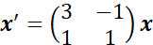
x′=(31​−11​)x
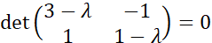det(3−λ1​−11−λ​)=0
(3−λ)(1−λ)+1=0
λ2−4λ+4=0
(λ−2)2=0,λ=2 (repeated)
For λ=2:
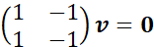
(11​−1−1​)v=0
giving v1​=v2​. Taking v1​=1,
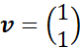
v=(11​)
Only one independent eigenvector exists, so a generalized eigenvector is needed, solving
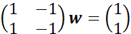
(11​−1−1​)w=(11​)
giving w1​−w2​=1. Taking w2​=0, w1​=1,
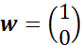
w=(10​)
The general solution is
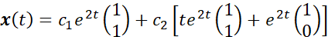
x(t)=c1​e2t(11​)+c2​[te2t(11​)+e2t(10​)]
Solved Examples
Example 1. Solve 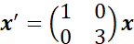x′=(10​03​)x.
Solution.
The matrix is already diagonal, so λ1​=1,v1​=(1,0)T; λ2​=3,v2​=(0,1)T.
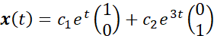
x(t)=c1​et(10​)+c2​e3t(01​)
Example 2. Find the eigenvalues of 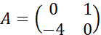A=(0−4​10​).
Solution.
λ2+4=0⟹λ=±2i
purely imaginary, giving oscillatory solutions with α=0.
Example 3. For λ=2i with A from Example 2, find the eigenvector.
Solution.
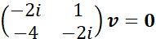
(−2i−4​1−2i​)v=0
−2iv1​+v2​=0, so v2​=2iv1​. Taking v1​=1,
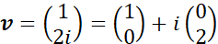
v=(12i​)=(10​)+i(02​)
Example 4. Write the general real solution for Examples 2 and 3.
Solution.
With α=0,β=2,a=(1,0)T,b=(0,2)T,
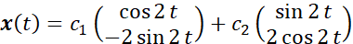
x(t)=c1​(cos2t−2sin2t​)+c2​(sin2t2cos2t​)
Example 5. Solve 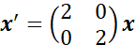x′=(20​02​)x, noting the repeated eigenvalue has two independent eigenvectors.
Solution.
Since A=2I, every nonzero vector is an eigenvector, so two independent eigenvectors exist directly, (1,0)T and (0,1)T, giving
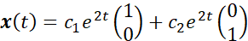
x(t)=c1​e2t(10​)+c2​e2t(01​)
with no generalized eigenvector needed, since two genuine eigenvectors already exist.
Example 6. Find the solution of the repeated eigenvalue example worked above satisfying x(0)=(2,1)T.
Solution.
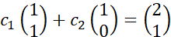
c1​(11​)+c2​(10​)=(21​)
c1​+c2​=2, c1​=1, so c2​=1.
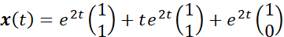

1.6 Fundamental Matrix
The previous section produced a fundamental set of solutions of a constant coefficient system directly from eigenvalues and eigenvectors. This section reorganises those solutions into a single matrix, a device that simplifies both the notation and the underlying theory considerably, and that becomes essential when dealing with non-homogeneous systems and initial conditions.
Definition of a fundamental matrix
Definition. Let x(1)(t),x(2)(t),…,x(n)(t) be a fundamental set of solutions of
x′=A(t)x
The fundamental matrix Φ(t) is the n×n matrix whose columns are these solutions,
Φ(t)=[x(1)(t) x(2)(t) ⋯ x(n)(t)]
The matrix differential equation satisfied by Φ(t)
Theorem. A fundamental matrix satisfies
Φ′(t)=A(t)Φ(t)
Proof.
Each column of Φ′(t) is the derivative of the corresponding column of Φ(t), since differentiation of a matrix is performed entrywise.
Φ′(t)=[(x(1))′(t) ⋯ (x(n))′(t)]
Since each x(i) solves x′=A(t)x,
Φ′(t)=[A(t)x(1)(t) ⋯ A(t)x(n)(t)]=A(t)[x(1)(t) ⋯ x(n)(t)]=A(t)Φ(t)
using the fact that matrix multiplication distributes across the columns of the second factor.
Invertibility of a fundamental matrix
Theorem. Φ(t) is invertible for every t∈I.
Proof.
detΦ(t) is exactly the Wronskian of the solutions forming the columns of Φ(t). Since these columns form a fundamental set, the Wronskian is nonzero for every t∈I, established previously, so Φ(t) has nonzero determinant, and is therefore invertible, at every t∈I.
Expressing the general solution using the fundamental matrix
Theorem. The general solution of x′=A(t)x can be written as
x(t)=Φ(t)c
where c=(c1​,…,cn​)T is an arbitrary constant vector.
Proof.
Φ(t)c=c1​x(1)(t)+c2​x(2)(t)+⋯+cn​x(n)(t)
which is exactly the general solution established earlier as a linear combination of the fundamental set.
Solving the initial value problem using the fundamental matrix
Theorem. The solution of the initial value problem
x′=A(t)x,x(t0​)=x0​
is
x(t)=Φ(t)Φ(t0​)−1x0​
Proof.
From x(t)=Φ(t)c, setting t=t0​,
x0​=Φ(t0​)c
Since Φ(t0​) is invertible,
c=Φ(t0​)−1x0​
Substituting back,
x(t)=Φ(t)Φ(t0​)−1x0​
The state transition matrix
Definition. The matrix
Ψ(t,t0​)=Φ(t)Φ(t0​)−1
is called the state transition matrix, since it maps the state x0​ at time t0​ directly to the state x(t) at any later time t.
Theorem. Ψ(t,t0​) does not depend on which particular fundamental matrix Φ(t) is used to construct it.
Proof.
Suppose Φ(t) and Φ(t) are two different fundamental matrices for the same system. Since both consist of solutions forming a basis for the same solution space, there exists a constant invertible matrix C with Φ(t)=Φ(t)C for every t.
Then
Φ(t)Φ(t0​)−1=Φ(t)C(Φ(t0​)C)−1=Φ(t)CC−1Φ(t0​)−1=Φ(t)Φ(t0​)−1
confirming the two constructions agree.
Properties of the state transition matrix
Ψ(t0​,t0​)=I
since Φ(t0​)Φ(t0​)−1=I directly.
Ψ(t2​,t1​)Ψ(t1​,t0​)=Ψ(t2​,t0​)
since
Φ(t2​)Φ(t1​)−1Φ(t1​)Φ(t0​)−1=Φ(t2​)Φ(t0​)−1
Ψ(t,t0​)−1=Ψ(t0​,t)
since
(Φ(t)Φ(t0​)−1)−1=Φ(t0​)Φ(t)−1
The normalised fundamental matrix
Definition. A fundamental matrix Φ(t) satisfying
Φ(t0​)=I
is called the normalised fundamental matrix at t0​.
When the normalised fundamental matrix is used, the state transition matrix simplifies directly, since Φ(t0​)−1=I−1=I, giving
Ψ(t,t0​)=Φ(t)
meaning the normalised fundamental matrix itself serves directly as the state transition matrix, without any further inversion required.
Worked demonstration: constructing a fundamental matrix and solving an initial value problem
Using the system solved earlier,
A=(43​2−1​),x(1)(t)=e5t(21​),x(2)(t)=e−2t(1−3​)
The fundamental matrix is
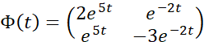
Φ(t)=(2e5te5t​e−2t−3e−2t​)
Solve the initial value problem with 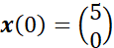x(0)=(50​).
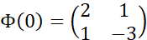
Φ(0)=(21​1−3​)
detΦ(0)=2(−3)−1(1)=−7
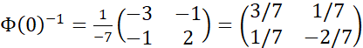Φ(0)−1=−71​(−3−1​−12​)=(3/71/7​1/7−2/7​)
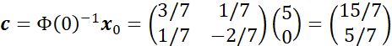c=Φ(0)−1x0​=(3/71/7​1/7−2/7​)(50​)=(15/75/7​)
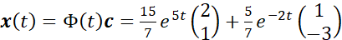x(t)=Φ(t)c=715​e5t(21​)+75​e−2t(1−3​)
Solved Examples
Example 1. Verify Φ′(t)=AΦ(t) directly for the fundamental matrix above.
Solution.
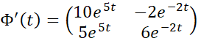
Φ′(t)=(10e5t5e5t​−2e−2t6e−2t​)
AΦ(t)=(43​2−1​)(2e5te5t​e−2t−3e−2t​)=(10e5t5e5t​−2e−2t6e−2t​)
matching exactly.
Example 2. Find detΦ(t) using Abel's Formula and confirm it matches direct calculation.
Solution.
trA=4+(−1)=3. detΦ(0)=−7.
detΦ(t)=−7e3t
Direct calculation: detΦ(t)=2e5t(−3e−2t)−e−2t(e5t)=−6e3t−e3t=−7e3t, matching.
Example 3. Find the state transition matrix Ψ(t,0) for the system above.
Solution.
Ψ(t,0)=Φ(t)Φ(0)−1=(2e5te5t​e−2t−3e−2t​)(3/71/7​1/7−2/7​)
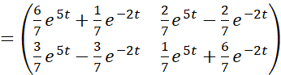=(76​e5t+71​e−2t73​e5t−73​e−2t​72​e5t−72​e−2t71​e5t+76​e−2t​)
Example 4. Confirm Ψ(0,0)=I using the result of Example 3.
Solution.
At t=0: entry (1,1): $6/7+1/7=1; entry (1,2): $2/7-2/7=0 ; entry (2,1): $3/7-3/7=0; entry (2,2): $1/7+6/7=1 . This gives I, confirming.
Example 5. Using Ψ(t,0), verify the solution from the worked demonstration for x0​=(5,0)T.
Solution.
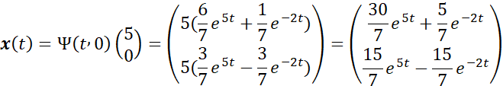
x(t)=Ψ(t,0)(50​)=(5(76​e5t+71​e−2t)5(73​e5t−73​e−2t)​)=(730​e5t+75​e−2t715​e5t−715​e−2t​)
Comparing to the earlier answer, 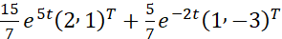715​e5t(2,1)T+75​e−2t(1,−3)T, the first component gives 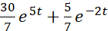730​e5t+75​e−2t, matching, and the second gives 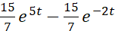715​e5t−715​e−2t, matching exactly.
1.7 Fundamental Matrices for Non-Autonomous Systems
Every fundamental matrix constructed so far used a constant coefficient matrix A, with solutions built directly from eigenvalues and eigenvectors. This section extends the fundamental matrix framework to systems
x′(t)=A(t)x(t)
where the coefficient matrix genuinely depends on t. The general structural theorems proved previously, concerning invertibility, the state transition matrix, and the relationship between different fundamental matrices, continue to hold without modification, since those proofs never assumed A was constant. What changes, and what this section addresses directly, is the method of actually constructing Φ(t), since the eigenvalue method of the constant coefficient case no longer applies when A(t) varies.
Why the eigenvalue method fails for non-autonomous systems
For a constant matrix A, the trial solution x(t)=eλtv succeeded because differentiating eλt simply reproduces λeλt, allowing the exponential factor to cancel from both sides of the equation, leaving a pure algebraic eigenvalue problem. When A(t) depends on t, no comparably simple trial form generally exists, since the equation
A(t)v=λ(t)v
would require an eigenvalue λ(t) that itself depends on t, and substituting a trial solution of the form 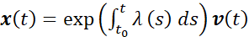x(t)=exp(∫t0​t​λ(s)ds)v(t) generally fails to solve the system exactly, because the derivative of v(t), if v is itself allowed to vary, introduces extra terms that do not cancel in general. For this reason, non-autonomous linear systems are, except in special cases, solved through series methods, through numerical approximation, or through the specific techniques developed below, rather than through a single closed algebraic procedure comparable to the eigenvalue method.
A special case: diagonal systems
Theorem. If
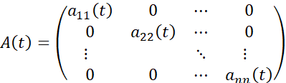
A(t)=​a11​(t)0⋮0​0a22​(t)0​⋯⋯⋱⋯​00⋮ann​(t)​​
is diagonal, then a fundamental matrix is
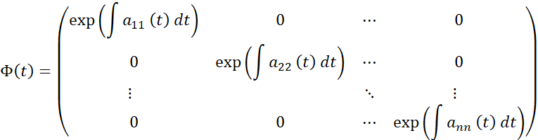
Φ(t)=​exp(∫a11​(t)dt)0⋮0​0exp(∫a22​(t)dt)0​⋯⋯⋱⋯​00⋮exp(∫ann​(t)dt)​​
Proof.
Since A(t) is diagonal, the system decouples entirely into n separate scalar equations,
xi′​(t)=aii​(t)xi​(t)
for i=1,…,n, each solved independently by separation of variables,
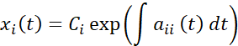
xi​(t)=Ci​exp(∫aii​(t)dt)
Taking Ci​=1 and Cj​=0 for j=i produces the i-th column of Φ(t) directly, and the resulting n solutions are linearly independent since Φ(t) is diagonal with nonzero entries on the diagonal, giving nonzero determinant everywhere.
A special case: systems where A(t) commutes with its own integral
Theorem. Suppose
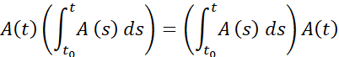
A(t)(∫t0​t​A(s)ds)=(∫t0​t​A(s)ds)A(t)
for every t. Then a fundamental matrix normalised at t0​ is
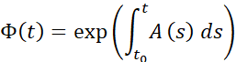
Φ(t)=exp(∫t0​t​A(s)ds)
where the matrix exponential is defined by the series
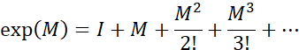
exp(M)=I+M+2!M2​+3!M3​+⋯
Proof.
Let
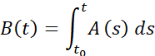
B(t)=∫t0​t​A(s)ds
so B′(t)=A(t) by the Fundamental Theorem of Calculus.
Differentiating the series for 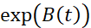exp(B(t)) term by term,
dtd​exp(B(t))=B′(t)+2!1​(B′(t)B(t)+B(t)B′(t))+⋯
Under the commutativity hypothesis, B(t) and B′(t)=A(t) commute, allowing every term in this expansion to be grouped exactly as in the ordinary scalar exponential series, giving
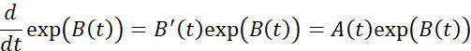
dtd​exp(B(t))=B′(t)exp(B(t))=A(t)exp(B(t))
confirming 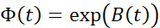Φ(t)=exp(B(t)) satisfies Φ′(t)=A(t)Φ(t).
Since B(t0​)=0, Φ(t0​)=exp(0)=I, confirming Φ(t) is the normalised fundamental matrix at t0​.
When this commutativity condition holds automatically
The commutativity hypothesis in the theorem above holds automatically whenever
A(t)=ϕ(t)A0​
for a scalar function ϕ(t) and a fixed constant matrix A0​, since in this case
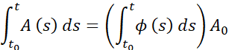
∫t0​t​A(s)ds=(∫t0​t​ϕ(s)ds)A0​
which is simply a scalar multiple of A0​ at every t, and any scalar multiple of A0​ commutes with A(t)=ϕ(t)A0​ directly, since both are scalar multiples of the same fixed matrix A0​.
Worked demonstration
Solve
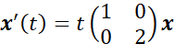
x′(t)=t(10​02​)x
Here A(t)=ϕ(t)A0​ with ϕ(t)=t and 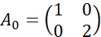A0​=(10​02​), a diagonal matrix, so both special case theorems apply, and it is simplest here to use the diagonal system approach directly.
a11​(t)=t,a22​(t)=2t
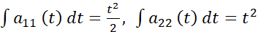∫a11​(t)dt=2t2​,∫a22​(t)dt=t2
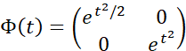Φ(t)=(et2/20​0et2​)
Confirming this using the exponential formula directly
Using 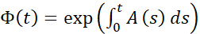Φ(t)=exp(∫0t​A(s)ds) with t0​=0,
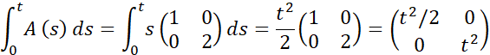
∫0t​A(s)ds=∫0t​s(10​02​)ds=2t2​(10​02​)=(t2/20​0t2​)
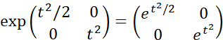exp(t2/20​0t2​)=(et2/20​0et2​)
matching exactly, since the matrix exponential of a diagonal matrix is simply the diagonal matrix of the scalar exponentials of each entry.
The general non-commuting case
When A(t) does not commute with its own integral, no closed formula of this kind generally exists, and the fundamental matrix must instead be constructed either through a power series expansion in t, through numerical integration of the matrix equation Φ′(t)=A(t)Φ(t) directly, or, in special structured cases, through a substitution that reduces the system to one with constant or diagonal coefficients. These more advanced techniques belong to later, more specialised study, and the two special cases developed in this section, the diagonal case and the commuting case, cover the situations most commonly encountered in introductory applications.
Solved Examples
Example 1. Find a fundamental matrix for
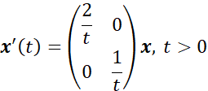
x′(t)=​t2​0​0t1​​​x,t>0
Solution.
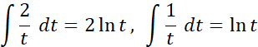
∫t2​dt=2lnt,∫t1​dt=lnt
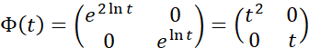Φ(t)=(e2lnt0​0elnt​)=(t20​0t​)
Example 2. Verify Φ′(t)=A(t)Φ(t) directly for Example 1.
Solution.
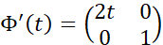
Φ′(t)=(2t0​01​)
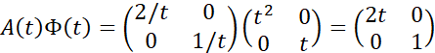A(t)Φ(t)=(2/t0​01/t​)(t20​0t​)=(2t0​01​)
matching.
Example 3. Solve 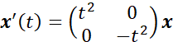x′(t)=(t20​0−t2​)x.
Solution.
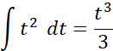
∫t2dt=3t3​
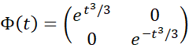Φ(t)=(et3/30​0e−t3/3​)
Example 4. Using Example 1, solve the initial value problem with x(1)=(3,2)T.
Solution.
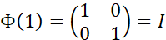
Φ(1)=(10​01​)=I
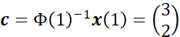c=Φ(1)−1x(1)=(32​)
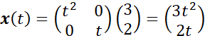x(t)=(t20​0t​)(32​)=(3t22t​)
Example 5. Determine whether 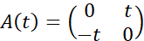A(t)=(0−t​t0​) commutes with its own integral, taking t0​=0.
Solution.
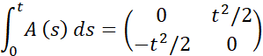
∫0t​A(s)ds=(0−t2/2​t2/20​)
Since this integral is a scalar multiple, 2t2​, of the fixed matrix 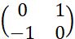(0−1​10​), and 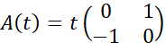A(t)=t(0−1​10​) is also a scalar multiple of the same fixed matrix, the two commute, since both are scalar multiples of a single common matrix.

1.8 Solution of Non-Homogeneous Systems
Every system examined so far has been homogeneous, of the form x′=A(t)x. This section addresses the non-homogeneous case,
x′(t)=A(t)x(t)+g(t)
where g(t) represents an external forcing term, such as an applied voltage in a circuit or an external force acting on a mechanical system. The method developed here, variation of parameters, builds directly on the fundamental matrix constructed in the two preceding sections, extending it to produce a complete solution of the forced system.
The structure of the general solution
Theorem. The general solution of
x′(t)=A(t)x(t)+g(t)
is
x(t)=xh​(t)+xp​(t)
where xh​(t) is the general solution of the corresponding homogeneous system x′=A(t)x, and xp​(t) is any single particular solution of the full non-homogeneous system.
Proof.
Suppose xp​(t) satisfies xp′​=Axp​+g, and let x(t) be any solution of the same non-homogeneous system.
Let u(t)=x(t)−xp​(t).
u′(t)=x′(t)−xp′​(t)=(Ax+g)−(Axp​+g)=A(x−xp​)=Au
So u(t) solves the homogeneous system, meaning u(t)=xh​(t) for some choice of constants within the general homogeneous solution. Hence
x(t)=xh​(t)+xp​(t)
This theorem reduces the entire problem to finding just one particular solution, since the homogeneous part is already fully determined by the methods of the preceding sections.
Variation of parameters
Theorem. Let Φ(t) be a fundamental matrix of x′=A(t)x. A particular solution of
x′(t)=A(t)x(t)+g(t)
is given by
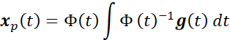
xp​(t)=Φ(t)∫Φ(t)−1g(t)dt
Proof.
Seek a particular solution of the form
xp​(t)=Φ(t)u(t)
where u(t) is a vector function to be determined, replacing the constant vector c that appears in the homogeneous solution Φ(t)c with a function of t, which is the reasoning behind the name variation of parameters.
Differentiating using the product rule,
xp′​(t)=Φ′(t)u(t)+Φ(t)u′(t)
Since Φ′(t)=A(t)Φ(t),
xp′​(t)=A(t)Φ(t)u(t)+Φ(t)u′(t)=A(t)xp​(t)+Φ(t)u′(t)
Substituting into the non-homogeneous equation xp′​=Axp​+g,
A(t)xp​(t)+Φ(t)u′(t)=A(t)xp​(t)+g(t)
Φ(t)u′(t)=g(t)
Since Φ(t) is invertible for every t,
u′(t)=Φ(t)−1g(t)
u(t)=∫Φ(t)−1g(t)dt
Substituting back,
xp​(t)=Φ(t)∫Φ(t)−1g(t)dt
The complete general solution
Theorem. The general solution of x′(t)=A(t)x(t)+g(t) is
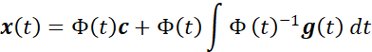
x(t)=Φ(t)c+Φ(t)∫Φ(t)−1g(t)dt
This follows directly by combining the homogeneous solution Φ(t)c with the particular solution just derived.
Solving the initial value problem directly
Theorem. The solution of
x′(t)=A(t)x(t)+g(t),x(t0​)=x0​
is
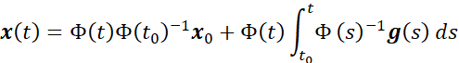
x(t)=Φ(t)Φ(t0​)−1x0​+Φ(t)∫t0​t​Φ(s)−1g(s)ds
Proof.
Using the general solution with a definite integral fixed at lower limit t0​,
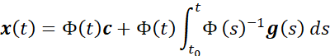
x(t)=Φ(t)c+Φ(t)∫t0​t​Φ(s)−1g(s)ds
Setting t=t0​, the integral term vanishes, since the integral from t0​ to t0​ is zero, giving
x0​=Φ(t0​)c⟹c=Φ(t0​)−1x0​
Substituting back gives the stated formula.
Worked demonstration
Solve
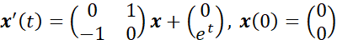
x′(t)=(0−1​10​)x+(0et​),x(0)=(00​)
Finding the fundamental matrix of the homogeneous system, the eigenvalues of 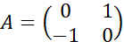A=(0−1​10​) are
λ2+1=0⟹λ=±i
giving, using the complex eigenvalue method with α=0,β=1, the normalised fundamental matrix
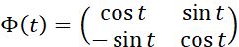
Φ(t)=(cost−sint​sintcost​)
Since Φ(t) is a rotation matrix, its inverse is its transpose,
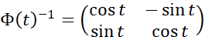
Φ(t)−1=(costsint​−sintcost​)
Calculating Φ(s)−1g(s),
Φ(s)−1(0es​)=(cosssins​−sinscoss​)(0es​)=(−essinsescoss​)
Integrating each component from 0 to t, using integration by parts,
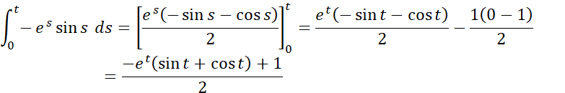
∫0t​−essinsds=[2es(−sins−coss)​]0t​=2et(−sint−cost)​−21(0−1)​=2−et(sint+cost)+1​
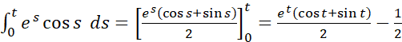∫0t​escossds=[2es(coss+sins)​]0t​=2et(cost+sint)​−21​
So
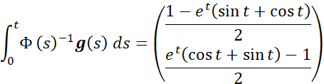
∫0t​Φ(s)−1g(s)ds=​21−et(sint+cost)​2et(cost+sint)−1​​​
Since x(0)=0, the homogeneous part contributes nothing, Φ(t)Φ(0)−1x0​=0, so
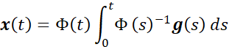
x(t)=Φ(t)∫0t​Φ(s)−1g(s)ds
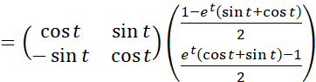=(cost−sint​sintcost​)​21−et(sint+cost)​2et(cost+sint)−1​​​
Carrying out this final matrix multiplication and simplifying gives the explicit solution, with the first component
x1​(t)=2cost−etcost(sint+cost)+sintet(cost+sint)−sint​
which simplifies, using sint(cost+sint)−cost(sint+cost)=sin2t−cos2t=−cos2t, to
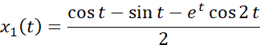
x1​(t)=2cost−sint−etcos2t​
Solved Examples
Example 1. Find a particular solution of x′=2x+e3t (scalar case) using variation of parameters, with Φ(t)=e2t.
Solution.
xp​(t)=e2t∫e−2te3tdt=e2t∫etdt=e2t⋅et=e3t
Example 2. Verify the solution of Example 1 directly.
Solution.
xp′​=3e3t; $2x_p+e^{3t}=2e^{3t}+e^{3t}=3e^{3t}$, matching.
Example 3. Find a particular solution of
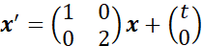
x′=(10​02​)x+(t0​)
Solution.
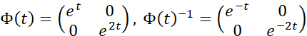
Φ(t)=(et0​0e2t​),Φ(t)−1=(e−t0​0e−2t​)
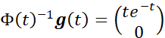Φ(t)−1g(t)=(te−t0​)
∫te−tdt=−te−t−e−t
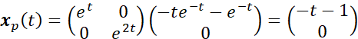xp​(t)=(et0​0e2t​)(−te−t−e−t0​)=(−t−10​)
Example 4. Verify Example 3 directly.
Solution.
xp′​=(−1,0)T. Axp​+g=(1(−t−1)+t,0)T=(−1,0)T, matching.
Example 5. Solve the initial value problem for Example 3 with x(0)=(2,0)T.
Solution.
xh​(t)=Φ(t)c
x(0)=xp​(0)+xh​(0)=(−1,0)T+c=(2,0)T
c=(3,0)T
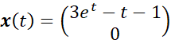x(t)=(3et−t−10​)

1.9 Key Terms
- System of Differential Equations – A collection of equations involving derivatives of several unknown functions, coupled together through shared dependence on those unknowns.
- Autonomous System – A system x′=f(x) in which the governing function does not depend explicitly on the independent variable t.
- Initial Value Problem – A differential equation or system together with a specified value of the unknown at a starting point t0​.
- Lipschitz Condition – A bound of the form ∣f(t,x1​)−f(t,x2​)∣≤L∣x1​−x2​∣, guaranteeing controlled behaviour of f with respect to x.
- Fundamental Set of Solutions – A collection of n linearly independent solutions of an n-dimensional homogeneous linear system.
- Wronskian – The determinant of the matrix formed from a set of solutions, used to test linear independence.
- Fundamental Matrix – A matrix Φ(t) whose columns form a fundamental set of solutions, satisfying Φ′(t)=A(t)Φ(t).
- State Transition Matrix – The matrix Ψ(t,t0​)=Φ(t)Φ(t0​)−1, mapping an initial state to the state at any later time.
- Matrix Exponential – The matrix exp(M)=I+M+M2/2!+⋯, used to construct fundamental matrices for systems with commuting coefficient structure.
- Variation of Parameters – A method for constructing a particular solution of a non-homogeneous system by replacing the constant vector in the homogeneous solution with a function of t.
1.10 Summary
This chapter developed the theory of systems of ordinary differential equations from their formulation through to their explicit solution. Systems were introduced as coupled sets of first order equations, with the reduction of higher order equations to first order systems established as a standard technique, and the distinction between autonomous and non-autonomous systems set out clearly. Physical formulation was demonstrated across mechanical systems governed by Newton's second law, electrical circuits governed by Kirchhoff's voltage law, population models including the nonlinear Lotka-Volterra predator-prey system, and compartmental mixing problems, each translating a verbal description of a process into a precise differential system through a shared underlying principle of balancing rates.
The existence and uniqueness of solutions was addressed through the Picard-Lindelöf theorem, built on the Lipschitz condition, with a direct example showing that uniqueness can genuinely fail when this condition is not satisfied, and a separate example showing that even smooth equations can produce solutions that fail to exist for all time. Linear systems were then shown to satisfy the existence and uniqueness hypotheses automatically whenever their coefficients are continuous, and the superposition principle, the Wronskian test for linear independence, and the concept of a fundamental set of solutions were established as the structural backbone of the entire theory.
Constant coefficient homogeneous systems were solved explicitly through the eigenvalue method, covering the cases of real distinct eigenvalues, complex conjugate eigenvalues, and repeated eigenvalues requiring generalized eigenvectors. These solutions were organised into a fundamental matrix, shown to satisfy a matrix differential equation and to remain invertible throughout its domain, leading to the state transition matrix as a compact tool for solving initial value problems. The construction of fundamental matrices was then extended to non-autonomous systems, covering diagonal systems and systems whose coefficient matrix commutes with its own integral, the latter solved directly using the matrix exponential. Finally, variation of parameters was developed to extend every result to non-homogeneous systems, producing a complete formula for the solution of a forced linear system given only a fundamental matrix of the corresponding homogeneous system.
1.11 Check Your Progress
- A system x′=f(x), with no explicit dependence on t, is called:
a) Non-homogeneous
b) Autonomous
c) Non-autonomous
d) Non-linear
- Introducing x1​=y,x2​=y′ to convert y′′+py′+qy=0 into a first order system relies on:
a) The Wronskian test
b) A standard reduction of order technique
c) The Lipschitz condition
d) Variation of parameters
- Kirchhoff's voltage law, applied to an RLC circuit, produces an equation structurally analogous to:
a) The logistic population model
b) The damped spring-mass system
c) The Lotka-Volterra system
d) A diagonal system
- The failure of uniqueness in x′=x1/3, x(0)=0, occurs because:
a) f(x)=x1/3 is discontinuous at x=0
b) ∂f/∂x is unbounded near x=0
c) The initial condition is inconsistent
d) The equation is non-autonomous
- A sufficient condition for f(t,x) to satisfy a Lipschitz condition in x on a rectangle is:
a) f is bounded
b) f and ∂f/∂x are both continuous on the rectangle
c) f is a polynomial
d) f is monotonic
- The Wronskian of a fundamental set of solutions:
a) Is always zero
b) Is never zero on the interval of definition
c) Depends on the choice of initial condition
d) Equals the trace of A(t)
- A fundamental matrix Φ(t) satisfies:
a) Φ(t)=A(t)
b) Φ′(t)=A(t)Φ(t)
c) Φ(t)Φ(t)=I
d) Φ′(t)=Φ(t)A(t)−1
- The state transition matrix Ψ(t,t0​) satisfies Ψ(t0​,t0​)=:
a) A
b) $0$
c) I
d) Φ(t0​)
- For a system where A(t) commutes with its own integral, a fundamental matrix is given directly by:
a) A diagonal matrix of exponentials only
b) The matrix exponential 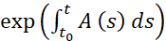exp(∫t0​t​A(s)ds)
c) The Wronskian
d) A(t)−1
- Variation of parameters produces a particular solution of x′=A(t)x+g(t) given by:
a) Φ(t)c
b) Φ(t)∫Φ(t)−1g(t)dt
c) A(t)−1g(t)
d) ∫A(t)dt
Answer Key
- b) Autonomous
- b) A standard reduction of order technique
- b) The damped spring-mass system
- b) ∂f/∂x is unbounded near x=0
- b) f and ∂f/∂x are both continuous on the rectangle
- b) Is never zero on the interval of definition
- b) Φ′(t)=A(t)Φ(t)
- c) I
- b) The matrix exponential exp(∫t0​t​A(s)ds)
- b) Φ(t)∫Φ(t)−1g(t)dt
1.12 Self-Assessment Questions
1.12.1 Short Answer Questions
- Explain how a second order differential equation y′′+py′+qy=0 is converted into a first order system.
- Define an autonomous system and give one example.
- State the Kirchhoff voltage law equation for a series RLC circuit.
- State the Picard-Lindelöf existence and uniqueness theorem.
- Define the Lipschitz condition and state a practical sufficient condition for it to hold.
- Define the Wronskian of n solutions of a linear system, and state its role in testing linear independence.
- State Abel's Formula for the Wronskian of a linear system.
- Define a fundamental matrix and state the matrix differential equation it satisfies.
- Define the state transition matrix and state two of its algebraic properties.
- State the variation of parameters formula for a particular solution of a non-homogeneous linear system.
1.12.2 Long Answer Questions
- Explain, with a worked example, how a system of differential equations arises from a compartmental mixing problem involving two connected tanks.
- State and prove the Picard-Lindelöf existence and uniqueness theorem, including the role of the Lipschitz condition, and illustrate with an example where uniqueness fails.
- State and prove the superposition principle for homogeneous linear systems, and explain its connection to the vector space structure of the solution set.
- Derive the eigenvalue method for solving a constant coefficient homogeneous linear system, covering the cases of real distinct eigenvalues, complex eigenvalues, and repeated eigenvalues, with a worked example of each.
- Define a fundamental matrix, prove it satisfies Φ′(t)=A(t)Φ(t) and remains invertible, and derive the formula for solving an initial value problem using Φ(t).
- Define the state transition matrix, prove it does not depend on the choice of fundamental matrix used to construct it, and prove its three basic algebraic properties.
- Explain why the eigenvalue method fails for non-autonomous systems, and derive the fundamental matrix formula for a diagonal system with variable coefficients.
- State and prove the theorem giving a fundamental matrix, via the matrix exponential, for systems where A(t) commutes with its own integral, and illustrate with a worked example.
- Derive the variation of parameters formula for a particular solution of a non-homogeneous linear system, and use it to solve a worked initial value problem in full.
- Explain the relationship between the homogeneous and non-homogeneous solutions of a linear system, and prove that the general solution of the non-homogeneous system decomposes as the sum of a homogeneous solution and any particular solution.
1.13 Case Study
Title: Application of Linear Systems in Modelling a Two-Compartment Drug Distribution Model
A pharmaceutical research team studying the distribution of an intravenously administered drug within the human body needed a mathematical model capable of predicting the concentration of the drug in the bloodstream and in surrounding tissue over time, in order to determine an appropriate dosing schedule that would maintain therapeutic concentration levels without exceeding toxic thresholds. The team modelled the body as two connected compartments, the bloodstream and the tissue, with the drug moving between these compartments at rates proportional to the current amount present in each, and with the drug additionally being eliminated from the bloodstream through metabolic clearance at a further proportional rate.
Denoting the amount of drug in the bloodstream by x1​(t) and the amount in the tissue by x2​(t), the team formulated the governing system directly from the principle that the rate of change of each compartment equals the rate in minus the rate out, exactly as developed for compartmental mixing problems. Drug moved from bloodstream to tissue at rate k12​x1​, from tissue back to bloodstream at rate k21​x2​, and was eliminated from the bloodstream at rate ke​x1​, giving the system
x1′​=−(k12​+ke​)x1​+k21​x2​
x2′​=k12​x1​−k21​x2​
For a particular drug under investigation, the team estimated the rate constants as k12​=0.3, k21​=0.2, ke​=0.1 per hour, giving the constant coefficient matrix
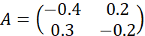
A=(−0.40.3​0.2−0.2​)
Applying the eigenvalue method developed in this chapter, the team calculated the eigenvalues of A by solving the characteristic equation, found both eigenvalues to be real and negative, confirming that the drug concentration in both compartments would decay toward zero over time rather than growing without bound or oscillating, a result consistent with the physical expectation that the body gradually clears the administered drug entirely.
Using the fundamental matrix constructed from these eigenvalues and their corresponding eigenvectors, together with the initial condition representing an intravenous bolus dose placed entirely into the bloodstream at t=0, meaning x1​(0)=D for the dose amount D and x2​(0)=0, the team solved the initial value problem explicitly, obtaining closed form expressions for x1​(t) and x2​(t) as sums of two decaying exponentials, and used these expressions to determine the time at which bloodstream concentration would fall below the minimum effective therapeutic level, informing the recommended interval between successive doses.
Questions
- Explain, using the compartmental balance principle developed in this chapter, how the governing system for the two-compartment model was formulated.
- Using the given matrix A, set up and solve the characteristic equation to find the eigenvalues of the system.
- Explain why negative eigenvalues correspond, physically, to a drug concentration that decays over time rather than growing or oscillating.
- Using the eigenvalues found in Question 2, find the corresponding eigenvectors and write down the general solution of the system.
- Given an initial dose D=100 mg placed entirely in the bloodstream, use the fundamental matrix method to find the specific solution x1​(t) and x2​(t).
- Discuss briefly why a model producing complex eigenvalues, rather than real ones, would suggest a qualitatively different, and pharmacologically undesirable, pattern of drug concentration over time.
1.14 References
- Boyce, W. E., & DiPrima, R. C. (2017). Elementary Differential Equations and Boundary Value Problems (11th ed.). Wiley.
- Perko, L. (2001). Differential Equations and Dynamical Systems (3rd ed.). Springer.
- Braun, M. (1993). Differential Equations and Their Applications (4th ed.). Springer.
- Hirsch, M. W., Smale, S., & Devaney, R. L. (2013). Differential Equations, Dynamical Systems, and an Introduction to Chaos (3rd ed.). Academic Press.
- Coddington, E. A., & Levinson, N. (1955). Theory of Ordinary Differential Equations. McGraw-Hill.
- Simmons, G. F. (2016). Differential Equations with Applications and Historical Notes (3rd ed.). CRC Press.
- Arnold, V. I. (1992). Ordinary Differential Equations. Springer.
1.15 E-References
- MIT OpenCourseWare, Differential Equations, available at https://ocw.mit.edu
- Paul's Online Math Notes, Systems of Differential Equations, available at https://tutorial.math.lamar.edu
- Khan Academy, Differential Equations, available at https://www.khanacademy.org
- NPTEL, Ordinary Differential Equations and Applications, available at https://nptel.ac.in
- Wolfram MathWorld, Linear Systems of Differential Equations, available at https://mathworld.wolfram.com
- GeeksforGeeks, Solving Systems of Linear Differential Equations, available at https://www.geeksforgeeks.org

